

**Cloud Computing**

**Assignment 1B**

**Individual Report**

**Tutorial Class**

**Class 1 – 14 6:30PM – 8:30PM**

Xuan Tuan Minh Nguyen

103819212

# Table Of Contents

Table Of Contents 2

Introduction 3

*1.* *An introduction* 3

*2.* *Main objective of the report* 3

The Implementation of the project 3

*1.* *Overview of the given infrastructure diagram* 3

*2.* *The implementation* 4

2.1.1. The VPC 4

2.1.2. Security Groups 5

2.1.3. EC2 Virtual Machine 6

2.1.4. RDS Database Instance 8

2.1.5. Network ACL 9

2.2.1. Photo Storage 9

2.2.2. Photo meta-data in RDS Database 10

2.2.3. Photo Album Website functionality 11

*3.* *Result* 11

Problems 13

Conclusion 13

Link to the website 14

# **Introduction**

## *An introduction*

Amazon Web Service, or AWS, is a service that is provided by Amazon which provide a spectrum of services that based on the mission of providing a transformative cloud computing platform that allows customers to use the empower of virtual machines to, for instance host a website, storing databases, etc. Beside from its foundation components are Amazon Elastic Compute Cloud (EC2) which provide a scalable virtual machines and Virtual Private Cloud (VPC) that enables custom network configurations. Amazon also introduces the Relational Database Services (RDS) and Simple Storage Service Bucket (S3 Bucket) which maximize the capability of storing databases over the cloud.

## *Main objective of the report*

In this project, I will demonstrate the use of EC2, VPC, RDS and S3 Bucket with a strict follow of the given infrastructure diagram to create a safe and displayable website that taken database from S3 bucket and display it through the EC2 instance. Additionally, I am also implement the network that banned any unauthorized connections to the instances. T

# **The Implementation of the project**

## *Overview of the given infrastructure diagram*

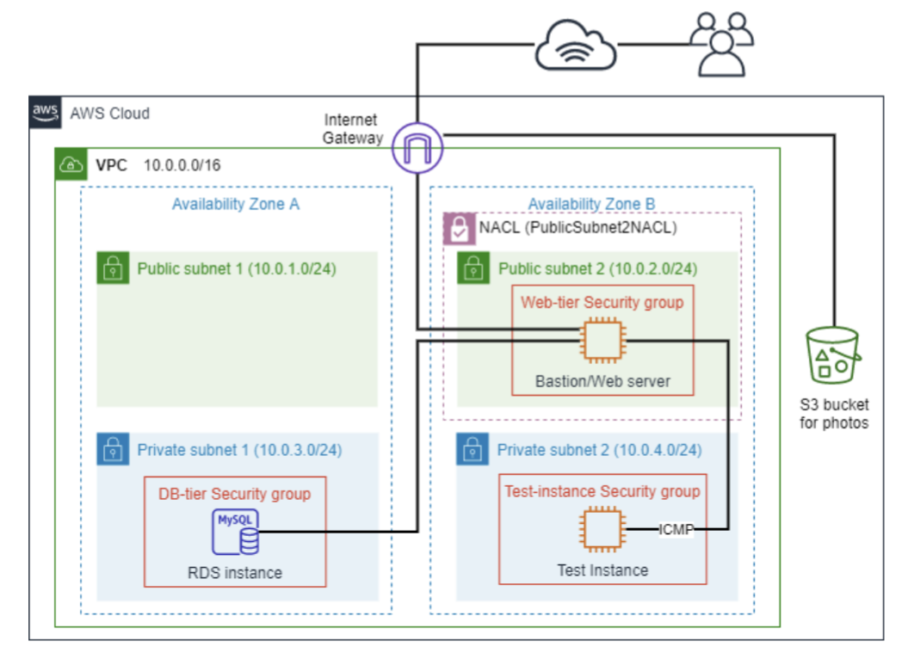

The diagram above illustrates the infrastructure that is required to be strictly implemented in order to create a safety network environment for the instances. There are four sub-networks inside the VPC that has a network of 10.0.0.0/16, which consists of two public subnet and 2 private subnets in two different availability zones. In addition, there are one main Bastion/Web server that allocated in the public subnet 2 (10.0.2.0/24) and two other instances that are allocated in the other two private subnets. In addition, there is a S3 bucket outside of the VPC that is also connected to the Internet Gateway.

## *The implementation*

### The VPC

In this step, I have created a Virtual Private Cloud infrastructure called XNguyenVPC, which consists of two Availability Zones (us-east-1a and us-east-1b) that holds two subnets (public and private). For the Public Subnet 2 in the Availability Zone B (10.0.2.0/24), I have attached it to the appropriate route table (XNguyenPublicRouteTable) that allows the subnet to interact with the internet gateway, allowing it to interact with the other VPCs and Internet. The other three will be route to the private route table and could only interact via the Public Subnet 2.

***Figure 2.1.1.1: Subnets, Route tables, Internet Gateway and the Resource Map of the VPC***

### Security Groups

I have created three security groups with necessary rule to control the inbound traffic that accessed to the instances. The first security group, which is TestInstanceSG, is allow for all traffic from anywhere to access to the instance on the subnet of 10.0.4.0/24. The

second security group is WebServerSG, is opened for HTTP, SSH from everywhere on the internet and the ICMP protocol from Test instance on the private subnet two (10.0.4.0/24). And the DBServerSG group will only allows MySQL (3306) connections from WebServerSG to inbound.

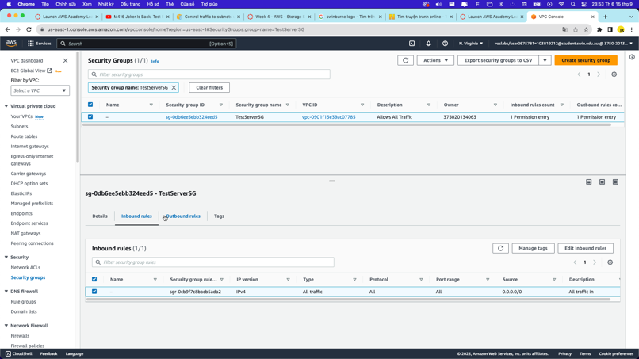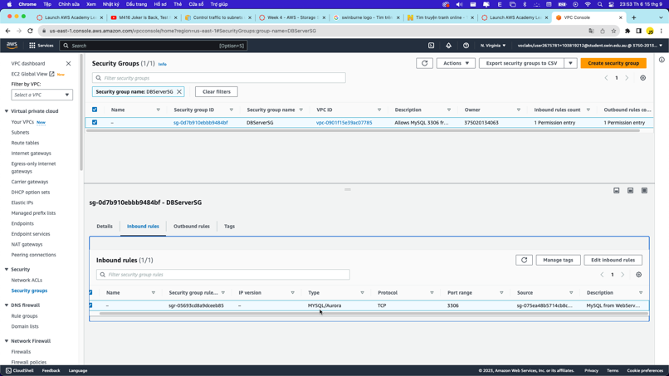

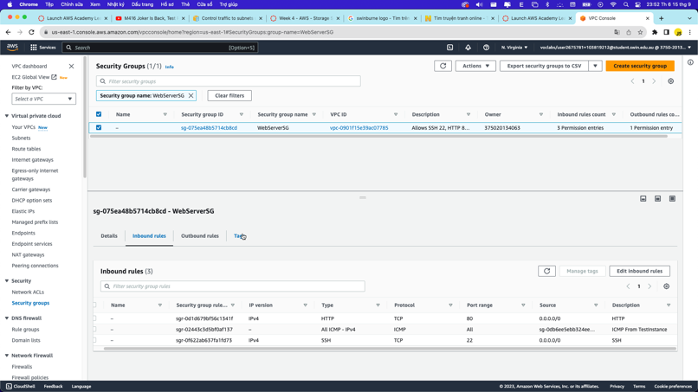

***Figure 2.1.2.1: Security Groups***

### EC2 Virtual Machine

In total, there are two virtual machines. The first one, which is the Bastion / Web Server instance, will be allocated to the Public Subnet Two (10.0.2.0/24) with the security group of WebServerSG. This machine will be serve as the gateway that both interact with the network via the internet gateway and also interact with the Test instance on the Private Subnet Two (10.0.4.0/24) and the RDS instance on the Private Subnet One (10.0.3.0/24) that will be use for PING purpose and SSH from the Bastion / Web Server instance.

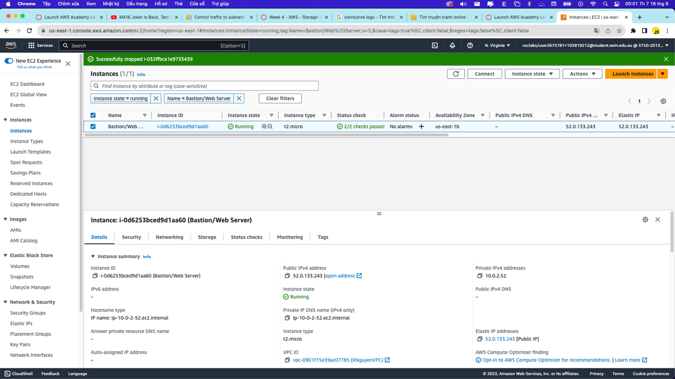

***Figure 2.1.3.1: Bastion / Web Server instance***

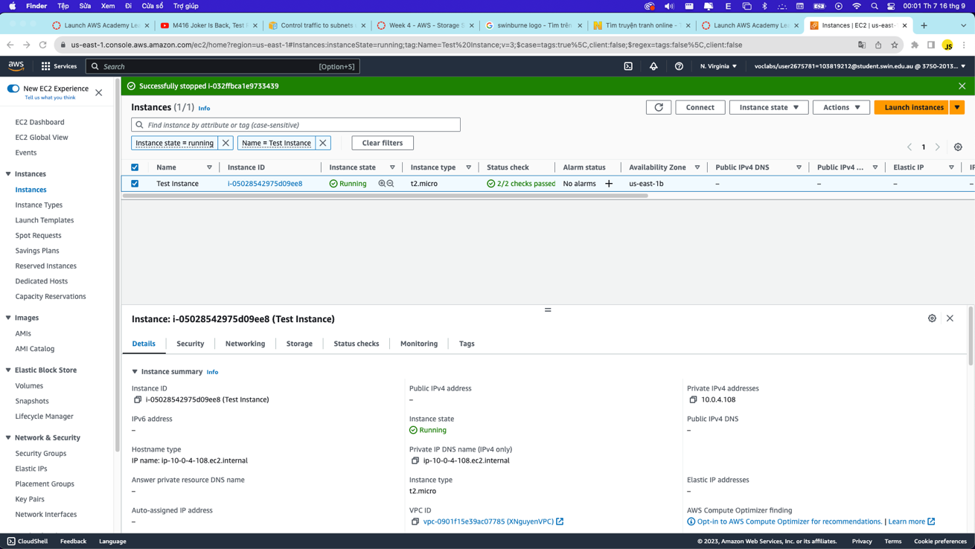

***Figure 2.1.3.2: Test Instance***

### RDS Database Instance

The RDS Database instance will be allocated into the Private Subnet One (10.0.3.0/24) and will be use as the main database for the website. The RDS instance will be run with the MySQL template and has the DBServerSG security group that only allows connection from the Bastion/Web Server instance.

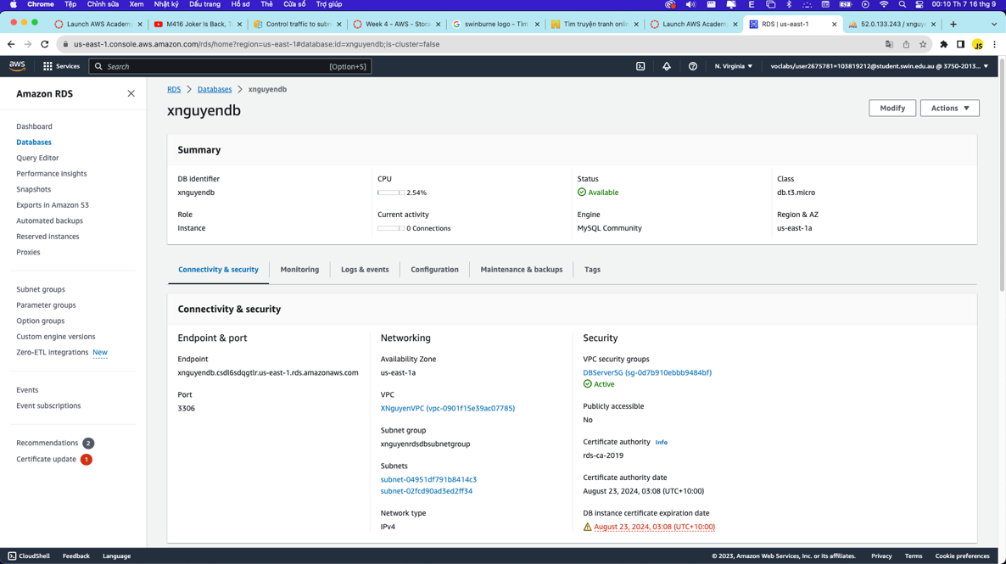

### 

***Figure 2.1.4.1: RDS Instance***

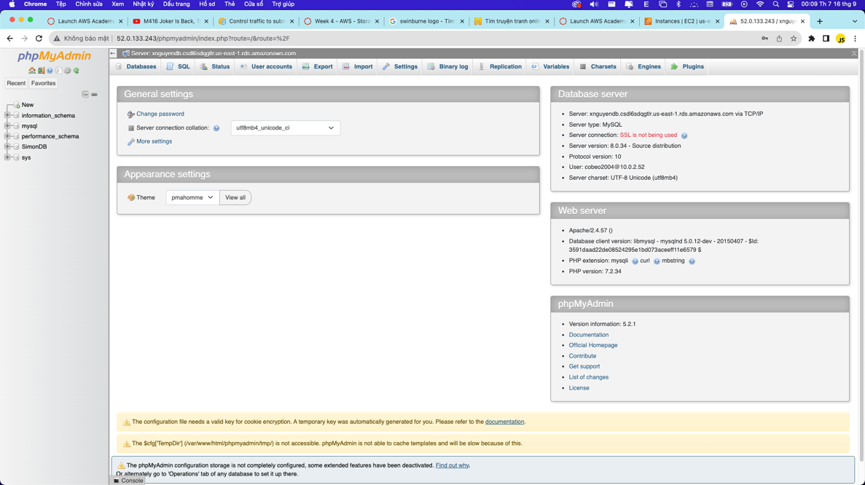

***Figure 2.1.4.2: MySQL of the RDS Instance***

### Network ACL

The Network Access Control List (Network ACL) is an important stateless layer of firewall that will defend the instance from the unwanted or malicious connection from the internet. In this context, I have placed the Network ACL on the Public Subnet Two (10.0.2.0/24) and fine-tuned the rule to only allows HTTP and SSH access from the internet gateway, ICMP and TCP traffic from Test Instance (10.0.4.0/24) and TCP traffic from the RDS instance (10.0.3.0/24) to ensure a safe connection and strictly followed the infrastructure.

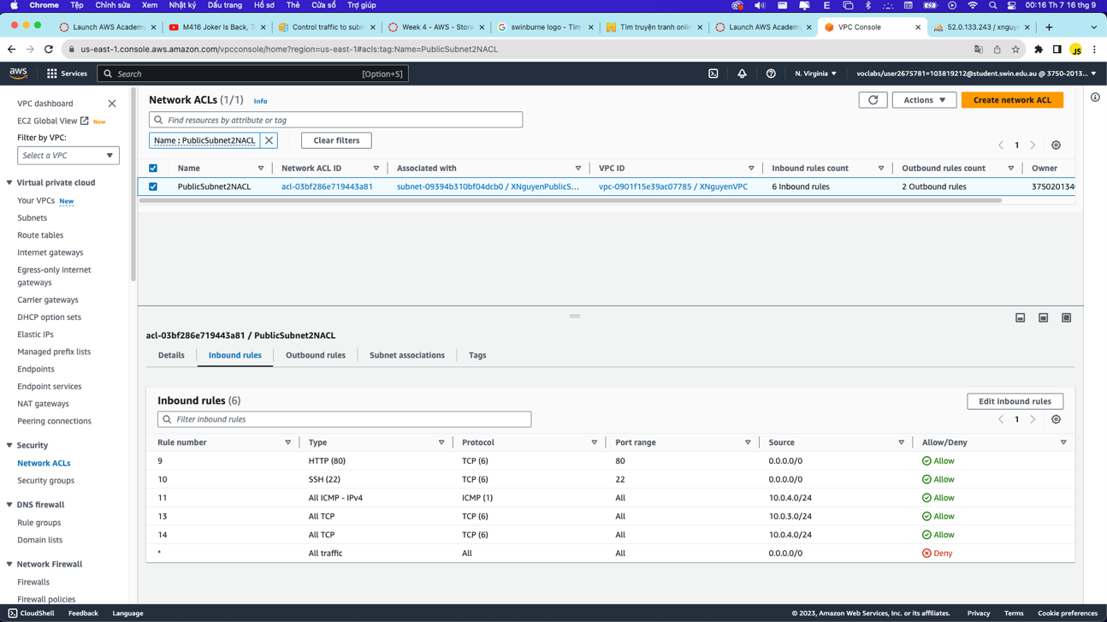

***Figure 2.1.5.1: Network ACL and rule***

### Photo Storage

S3 bucket is a reliable platform that helps storing many kinds of objects on the cloud. For photo storing purpose, I have used the S3 bucket for storing the Swinburne image. In addition, I have applied an appropriate policy that only allows users to only get the object that I uploaded to the bucket.

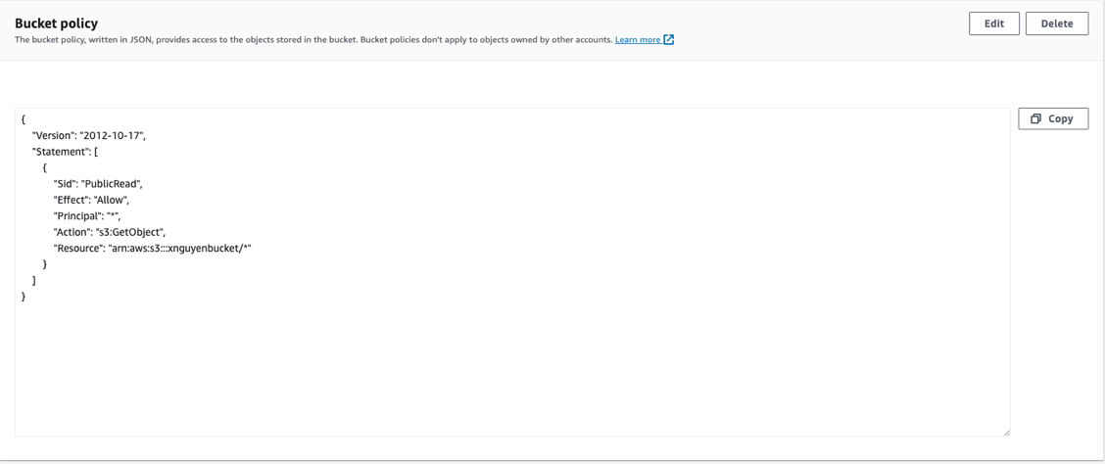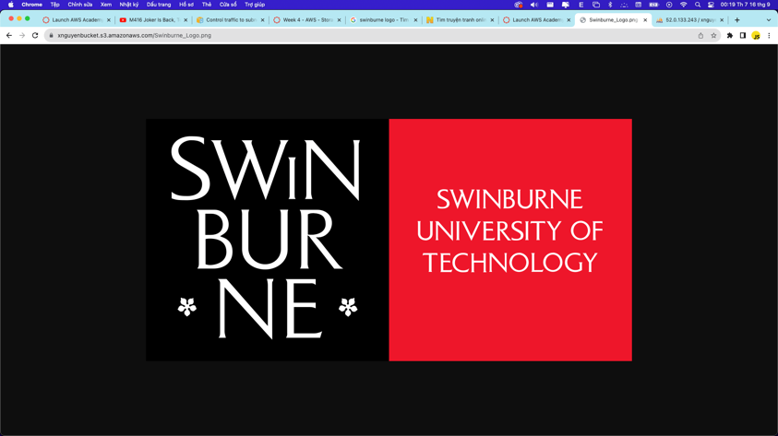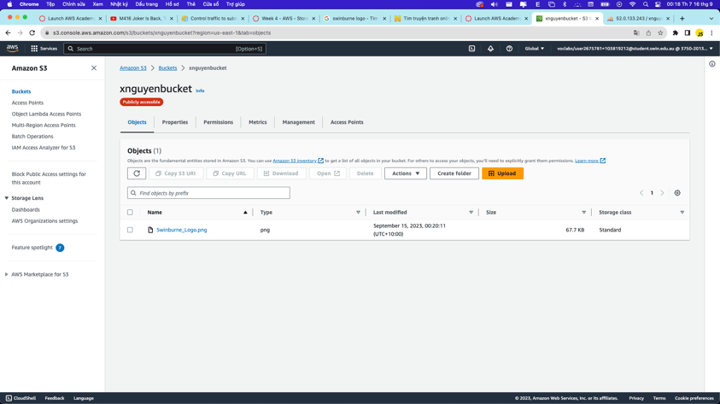

***Figure 2.2.1.1: Bucket, Object of the bucket and Bucket’s policy***

### Photo meta-data in RDS Database

I have created a table on the RDS instance’s MySQL that has the photo title, description of the photo, the creation date of the photo, the keywords and the reference to the photo on the S3 Bucket. I also added a sample that is required by the school to the table.

***Figure 2.2.2.1: Data on the RDS Instance***

### Photo Album Website functionality

In this implementation step, I have changed the required information on the constants.php and uploaded it to the Bastion/Web Server instance via Cyberduck.

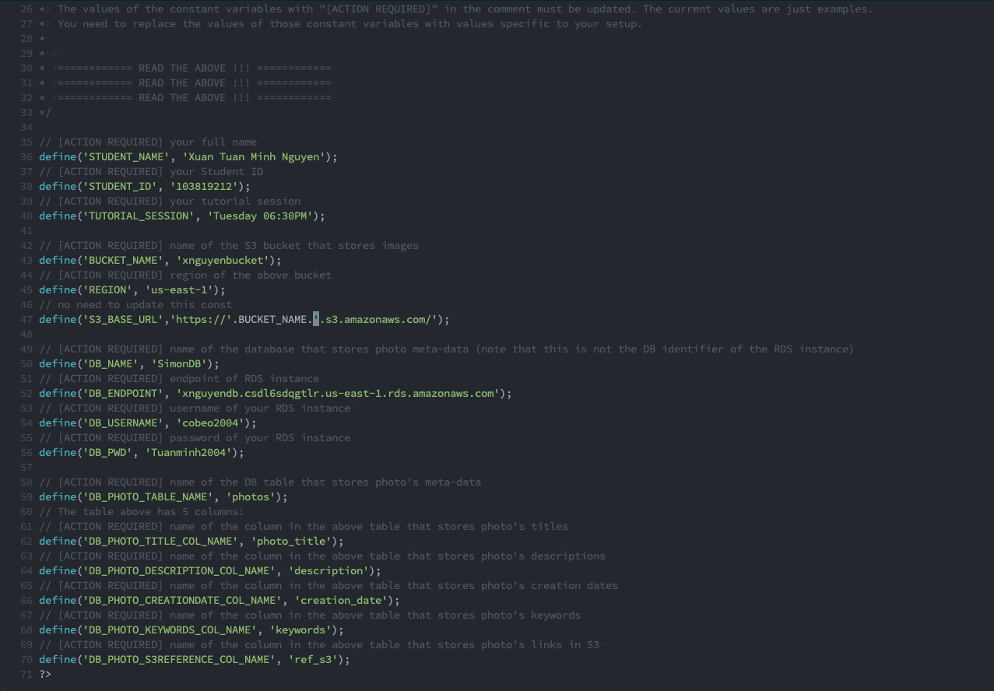

***Figure 2.2.3.1: Content of constants.php***

## *Result*

As a result, I have successfully attempted to SSH into the Test instance and PING back the Bastion/Web Server instance. I also got accessed to the RDS instance and S3 bucket for storing the necessary database and displayed it.

***Figure 3.1: SSH into Bastion/Web Server instance***

***Figure 3.2: SSH into Test instance***

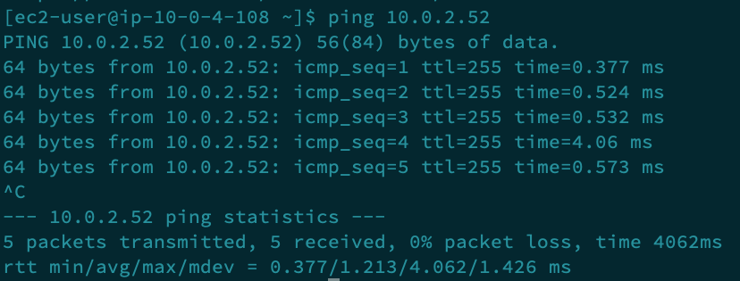

***Figure 3.3: PING Bastion/Web Server instance from Test instance***

***Figure 3.4: Web page***

# **Problems**

During the assignment, I have faced multiple problems, which majority of them are wrong or forgot to config essential settings. However, the biggest error that I have faced is when I configure the network access control list (Network ACL). At first, I misconfigured both of the inbound and outbound traffic to be the same and with a very high rule number. As a result, I could not access to PHPMyAdmin, Test instance that is allocated on the private subnet two (10.0.4.0/24) and the photoalbum page. In addition, I also faced with the policy error for the S3 bucket and the permission inside the terminal that denied me from accessing the webpage. However, I have managed to resolved the problem that successfully overcome it.

# **Conclusion**

In general, I have successfully implemented a web page using of EC2 instance, VPC, RDS and S3 Bucket. I have strictly followed the network infrastructure diagram in order to create a safe environment for the instances to work fluently. Although I have faced some challenges while doing this assignment, but I have managed to resolve the problem and learn new lessons from it. This project is a solid foundation for my future career and is a valuable project that contains lots of new knowledges for me to learn.

# **Link to the website**

Link: http://52.0.133.243/cos20019/photoalbum/album.php